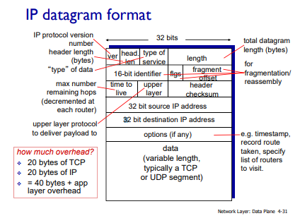

* IP Fragmentation
  + Network links have MTU(max transfer size) - latest possible link level frame
    - Different link types, different MTUs
  + Large IP datagram divided(“fragmented”) within net
    - One datagram becomes several datagrams
    - “Reassembled” only at final destination
    - IP header bits used to identify, order related fragments.

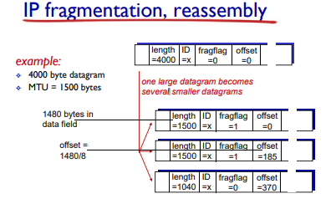

* IP Addressing
  + IP Address: 32-bit identifier for hoster, router interface
  + Interface: connection between host/router and physical link
    - Routers typically have multiple interfaces
    - Host typically has one or two interfaces (eg. wired ethernet, wireless 802.1)
* Subnets
  + IP Address:
    - Subnet part - high order bits
    - Host part - low order bits
  + What?
    - Device interfaces with same subnet part of IP address
    - Can physically reach each other without an intervening router.
  + How?
    - To determine the subnets, detach each interface from its host or router, creating islands of isolated networks
    - Each isolated network is called a subnet.
* CIDR: Classless InterDomain Routing
  + Subnet portion of address of arbitrary length
  + Address format: a.b.c.dx, where x is the # bits in the subnet portion of address.
* How to get an IP Address
  + Hard-coded by system admin in a file
    - Windows: control-panel->network->configuration- >tcp/ip->properties
    - UNIX: /etc/rc.config
  + DHCP: Dynamic Host Configuration Protocol
    - Dynamically get address from as server
      * “Plug and play”
* DHCP
  + Allow host to dynamically obtain its IP addres from network server whenit joins network
    - Can renew its lease on address in use
    - Allows reuse of address (only hold address while connected)
    - Support for mobile users who want to join network (more shortly)
  + Overview
    - • host broadcasts “DHCP discover” msg [optional]
    - • DHCP server responds with “DHCP offer” msg [optional]
    - • host requests IP address: “DHCP request” msg
    - • DHCP server sends address: “DHCP ack” msg

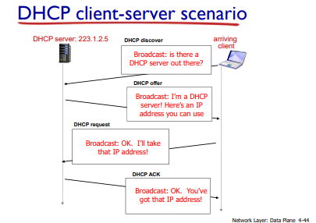

DHCP

* + DHCP can return more than just allocated IP address on subnet
    - Address of first-hop router for client
    - Name and IP address of DNS server
    - Network mask(indicating network versus host portion of address)

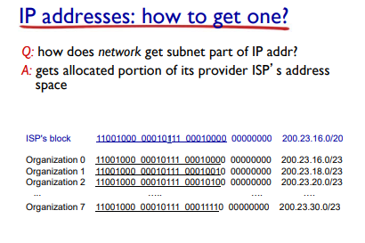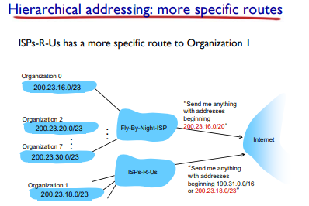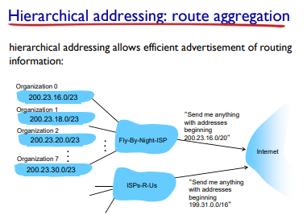

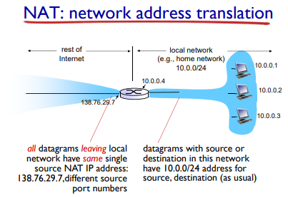

* NAT: